Kol Simcha Torah Gazette
For rosh Hashanah 5787
Vol 11 Issue 1 (Whole #512) Tishrei 1-2 5787/ September 12-13, 2026
Printed L’illuy nishmas Nechama bas R’ Noach, a”h
For a free subscription, please forward your request to keren18@juno.com
Past emails can be found on the website ShabbosStories.com under Brooklyn Torah Gazette
A 3-Step Plan for Change
This Rosh Hashanah
By Slovie Jungreis-Wolff



Forget resolutions that die by January 2nd. This ancient 3-step framework is built for change that actually sticks.

This is the time of year when Jews around the world pause to look inward and reflect on the year that's passed. Starting on the first day of Elul (the Hebrew month leading up to the High Holidays) and building until Rosh Hashanah, the shofar sounds like a spiritual alarm clock, waking you up to the chance for real change.
But if you just hear the blast without doing the inner work, it's no different than hearing music at a concert: stirring in the moment, then forgotten. This season calls for something deeper. It calls for renewal that actually propels you forward.
Here is a practical plan to make these days count:

- Spiritual Accounting
Pause and take stock of the past year with honesty and compassion. Think about the times you were thoughtless, when you hurt someone, or acted out of impatience. Recall your words, your tone, your actions.
Beyond your own life, think about the experience of Jews around the world. Your brothers and sisters have suffered through war, hatred, violent protests, massacres, and modern-day blood libels. You are one family, and you feel each other's pain.

Spiritual Exercise
Ask yourself:
Growth as an individual: Where did you grow this year? Where did you fall short? Where are you stuck? What pattern do you keep returning to that you now want to break? Which relationships need healing, forgiveness, or a word of thanks? Are you holding onto a grudge? How do you value your time? Is your life all about filling your bank account while your spiritual account sits empty?
Growth as a people: Your nation has endured inconceivable devastation and loss. It's easy to grow complacent, to sleepwalk through the sorrow. Do you stop, look up from your work, and take even a moment to feel when a Jew is attacked somewhere in the world? Ask yourself what you can do to make a difference. How can you strengthen your bond to your people and to God? Can you live more proudly as a Jew? Any mitzvah you take on becomes your answer to the hatred we're facing.

2. The Path to Return
Teshuva means "return," coming back to the person you were meant to be, the best version of you: a little kinder, a little more generous, a little more aware of your relationships. You rediscover your greatness, your spark, your inner holiness.

Here are the three steps:
Vidui (confession): Acknowledge your flaws and mistakes honestly. This path isn't about guilt or anxiety. Making a mistake doesn't make you a mistake. Start by naming, honestly, where you want to change.
Charatah (regret): Once you've faced your character honestly, stop making excuses. Don't rationalize, defend, or blame. Let yourself feel real remorse for whatever damage you caused, to yourself or to others.
Kabbalah al ha'atid (commitment): Resolve to do better in the year ahead. This isn't a New Year's resolution that fades by January 2nd. Growth isn't sudden or dramatic; it's small, steady steps up your own spiritual mountain. You need a real plan to back up your commitment to change.
You'll stumble and fail sometimes, and that's fine, as long as you keep returning to your promise to change through action. Know your mission. Know that you are unique in this world.

3. Crowning a Power Bigger Than Yourself
On Rosh Hashanah, a central theme of the prayers is malchiyot, kingship. You recognize that you are mortal, that life is fragile, that you are a human being with finite energy and limited years. God is called the "King of Kings." Your days are in your Creator's hands. On this day, you crown G-d and take in the majesty of the universe.
How do you connect to this idea of making kingship? When you crown G-d as your King, you realize your soul can lead your decisions. Your values guide you. You live with inspiration and wake up with purpose.

Spiritual Exercise
Find some quiet time to ask yourself: Who rules your life? Does your ego get in the way? Does fear paralyze you? Is social media in charge of your self-worth? Is your phone in charge of your time? Do you give in to impulses against your better judgment?
During these days, empower your soul. Each morning, before checking your phone, name three blessings in your life and give thanks for them. Do one generous act without expecting anything back. Apologize to someone you've hurt. Forgive and let go of anger and bitterness. Recognize how fragile it is to be human.
There's only one you in the world, for a reason. This is the time to rediscover your goodness, your inner greatness, your strengths and your passions. Embrace the power of these days.

Reprinted from the aish.com website.

Focusing on the Jew’s Obligation to Do Teshuva, Prayer and Charity
From the Teachings of the Lubavitcher Rebbe
Rabbi Menachem Mendel Schneerson, Zt”l
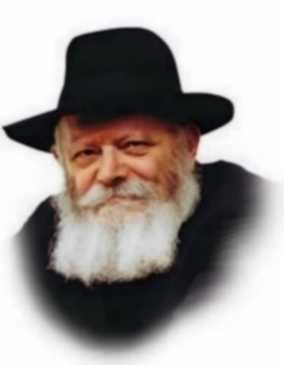
This Shabbat and Sunday are the holy days of Rosh Hashana. Traditionally, the High Holidays are associated with Teshuva, Tefila and Tzedaka - repentance, prayer and charity - which together form the three pillars of our service of G-d. The usual translation of these three concepts do not, however, convey their true Jewish essence.

The Exact Translation of Teshuva is “Charata”
Teshuva is usually rendered "repentance." However, the exact translation of "repentance" is "charata."
Charata stresses a movement toward a new path of action by the individual. He regrets that he committed an evil deed, or failed to perform a good one, and now wishes to conduct himself in a new manner. Teshuva, on the other hand, signifies return. A Jew is essentially good, and his innermost desire is to do what is right. It is only due to various circumstances, wholly or partly beyond his control, that he has erred. This is the Jewish concept of teshuva - a return to his roots and origins, to his innermost self, revealing his innate personality, which will now become the master of his life.

The More Accurate Translation of
Prayer is “Bakasha” – a Request
Tefila is generally translated as "prayer." Yet the more accurate translation of prayer would be "bakasha."
Similar to teshuva and charata, tefila and bakasha are antonyms. Bakasha means a request, a plea. Tefila means "to attach oneself." Bakasha emphasizes a request to the Alm-ghty to grant us our needs. However, when we lack or desire nothing, our asking is superfluous. Tefila signifies attaching oneself to G-d, and is relevant to everyone at all times.
Every Jew has a soul that is bound and connected to G-d. At times, these ties to the Alm-ghty may become weakened. To correct this, we have specific times during the day for tefila in order to renew and strengthen our ties with G-d. Hence, even for those who lack nothing material, there exists the concept of tefila, "wanting to get closer to G-d," so to speak. It is the means of strengthening the bond and attachment between the Jew and his Creator.

The More Accurate Word for “Charity” is Chesed
Tzedaka is often translated as "charity." But the more accurate word for charity is actually "chesed." The word chesed stresses the kindness of giving. This concept does not demand that the recipient be deserving, nor the donor obligated to give. Instead, out of goodness, he gives. Tzedaka, on the other hand, comes from the Hebrew word meaning "justice," signifying that justice demands of the Jew that he give, and for two reasons: First, he is not giving of his own, but only what has been entrusted to him by G-d to give to others. Second, since everyone depends on the Alm-ghty to provide for his needs, one is obligated to repay "measure for measure" and give to others.

Reprinted from the Rosh Hashanah 5764/2003 (Issue #788) email of L’Chaim, a publication of the Lubavitch Youth Organization in Brooklyn, NY. Adapted from a talk of the Lubavitcher Rebbe.

Rav Avigdor Miller on
The Test of Money

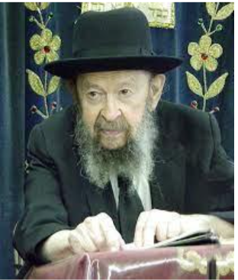

QUESTION: Why is it that when Jews acquire money, many times they seem to weaken in their service of Hashem?
ANSWER: How is it that people who become wealthy tend to forsake the principles of their fathers?
Now this is something that’s a well-known phenomenon. It’s constantly reiterated in the Scriptures, in the Tanach. וישמן ישרון ויבעט – Yeshurun became fat. The righteous nation became fat and began kicking (Devarim 32:15). It’s like a cow. A cow, if you don’t feed it too much, it’s docile. But once you give it too much food, then if you come to milk it, it’ll give you a kick in the face.
And that’s how children are too, by the way. They’re overfed today with too much candy and ice cream. And that’s why they’re so fresh. If they had to go to work in order to support themselves, then you’d see it’ll be a much more decent population.
Money is a great test.
Now, for good people money is a glorious opportunity. They become more grateful to Hashem and they utilize their wealth for the support of the Torah causes; and they become like Rabbi Akiva or like Raban Gamliel or like Rabbi Tarfon or like Rabbi Elazar ben Azarya, all the great people of our history who knew how to live with money.



But those that are not trained, those who are not prepared for wealth are ruined by wealth. Like Shlomo HaMelech said: ראש ועשר אל תתן לי – Don’t give me extreme wealth or extreme poverty, הטריפני לחם חקי – Give me just enough (Mishlei 30:8).
And therefore, it’s a great test and very many people have stumbled and have fallen because of this test.

Reprinted from a recent email of Torah Avigdor based on a February 1982 question-and-answer session from a classic Thursday night hashkafah lecture of Rav Avigdor Miller, zt”l.

Thoughts that Count
for Rosh Hashana

For You are He who remembers forever all forgotten things. (Musaf Rosh Hashana Amida)
One of the great Chasidic masters said of this verse: G-d remembers only that which a person forgets. If a person sins but he remembers the sin and it troubles him, G-d forgets it. But if he sins and he forgets about the sin, i.e., it doesn't bother him, G-d remembers it. The same is true of mitzvot (commandments). If he does a mitzva and remembers it, always thinking how great he is to have performed the mitzva, G-d forgets it. But if he does a mitzva and forgets about it, i.e., he doesn't become impressed with himself over it, G-d remembers it.

The Cry of the Shofar
The word used in the Torah to describe the sound of the shofar also denotes the sound of someone crying. There are two types of crying sounds. The first is like the moaning and crying of a person in pain, which is slightly drawn out. Another type of crying is tightly spaced short sobs. And sometimes, the first turns into the second; longer sounds followed by the shorter sounds. The first category of sounds are called shevarim, the second are teru'ot and the combination are shevarim-teru'ot. Each type of crying must have a single long sound, called a tekiah, preceding and following.

Good Wishes on Rosh Hashana
Reb Menachem Mendel of Lubavitch said: "Every person is accompanied by two angels when he returns home from the synagogue. After the evening prayers of Rosh Hashana, when they hear each person wishing his neighbor with a pure heart - 'May you be inscribed and sealed for a good year' - they soar aloft and appear as defense attorneys in the Heavenly Court, where they plead that the well-wishers be granted a good and sweet year, as well."

Between Rosh Hashana and Yom Kippur
Between Rosh Hashana and Yom Kippur, we are given a period of seven days, containing every day of the week - one Sunday, one Monday, and so forth. This complete week, neither more nor less, enables us to atone and repent for any wrong deeds accounted for during the previous year, and to better our way of life in the new year. That we have been given a complete week in which to accomplish this is significant: Spending the Sunday of this week as we should, and making the most of the time, serves as an atonement especially for the wrong done on all the Sundays of the previous year. The same is true of the repentance done on Monday for all Mondays, etc. (The Lubavitcher Rebbe)

Reprinted from the Parshat Nitzavim-Vayeilech 5763/2003 (Issue #787) email of L’Chaim, a publication of the Lubavitch Youth Organization in Brooklyn, NY.

A man once had a strong urge to see Eliyahu HaNavi, and he went to his Rav to discuss this with him. The Rav said, “Next week will be Rosh Hashanah. Travel to a certain city and stay by a certain widow, and there you will see Eliyahu HaNavi. However, make sure you bring along a lot of provisions, since this woman is very poor and she is not able to put up guests.”
The man was very pleased. He loaded a wagon with food and drink and went on his way with his wife to that city. When he arrived, he asked the townsfolk for directions to the house of that certain widow. They told him that there were two widows with the same name in that city, one lived alone and the other one had four children.
The man thought to himself, certainly, the Rav meant the widow with four orphans since he told me to bring a lot of provisions. The man went to the house of the widow and asked to stay with her for Rosh Hashanah.
“How can I host you?!” replied the widow nervously, “I am having difficulty feeding my children, how can I feed you?” the man replied, “Do not worry. I have brought enough food for all of us.”
She said, “And where will you sleep? I do not have a bed for you.” He answered, “Don’t worry. My wife and I will sleep on mattresses on the floor.” The
widow agreed and for the first time in their lives the children celebrated the holiday with much splendor and the joy was immense. This is how they spent Rosh Hashanah.
After Yom Tov, the man went home, went back to his Rav, and said, “I did as you instructed, now how can I be able to see Eliyahu HaNavi?”
The Rav was amazed and said, “What?! The entire time you were there you did not see Eliyahu HaNavi? If this is so, Yom Kippur is approaching. Pack your things and go back to her, then on Yom Kippur you will certainly merit to see Eliyahu HaNavi!”
So once again, the man loaded his wagon with much food and drink and went to the house of the widow. When he arrived at the house, he overheard the four orphans asking their mother, “How will we be able to fast on Yom Kippur? We are hungry, and it has already been a week since we ate.”
Their mother replied, “My dear children, On Rosh Hashanah, HaKadosh Baruch Hu sent us Eliyahu HaNavi, and he brought much food with him. Perhaps for Yom Kippur as well we will be worthy, and Eliyahu HaNavi will come back and bring us food for the Seudah Ha’mafsekes.”
Just at that moment the man opened the door and went in. He then understood an amazing thing you do not have to go far to look for Eliyahu HaNavi. The secret is that Eliyahu HaNavi is hidden within every person and can be seen with how one interacts with his fellow man.
The Pasuk (Devarim 30:14) mentions three things, mouth, heart, and deed. Eliyahu HaNavi can be a part of us in all of these ways. By saying the right thing at the right time, one can make someone feel better. By thinking of another at the right time, he can be considerate of another. By doing something for others he can help another person. This is how the Torah and Eliyahu HaNavi can be a part of us in speech, thought, and deed! (B’Nifleosecha Asicha)

Reprinted from the Parshas Nitzavim 5786 email of Rabbi Yehuda Winzelberg’s Torah U’Tefillah.

My Father Carried His Holocaust Story His Entire Life. He Never
Asked Us to Carry it, Too.
By Rabbi Avi Shafran
It was only as an adult living with my own family that I learned about my father’s youth.

Although my parents raised me from my birth in Baltimore and I had the happiest of childhoods, I only came to really know my father, Rabbi Simcha Shafran, who died in 2016 at 91, in the final 30-odd years of his life.
That’s because he spoke very little about his life before his immigration to the United States in 1947, and his becoming a citizen shortly thereafter. And I was too stupid to ask him about those years.
It was only around 1990, as an adult living with my own family in Providence, Rhode Island, that I learned about his youth.
The lesson arrived in the mail, on a cassette tape sent me by someone who had recorded a speech my father delivered to an audience on Holocaust Remembrance Day. He apparently felt more comfortable relating his story to strangers than to his own children.

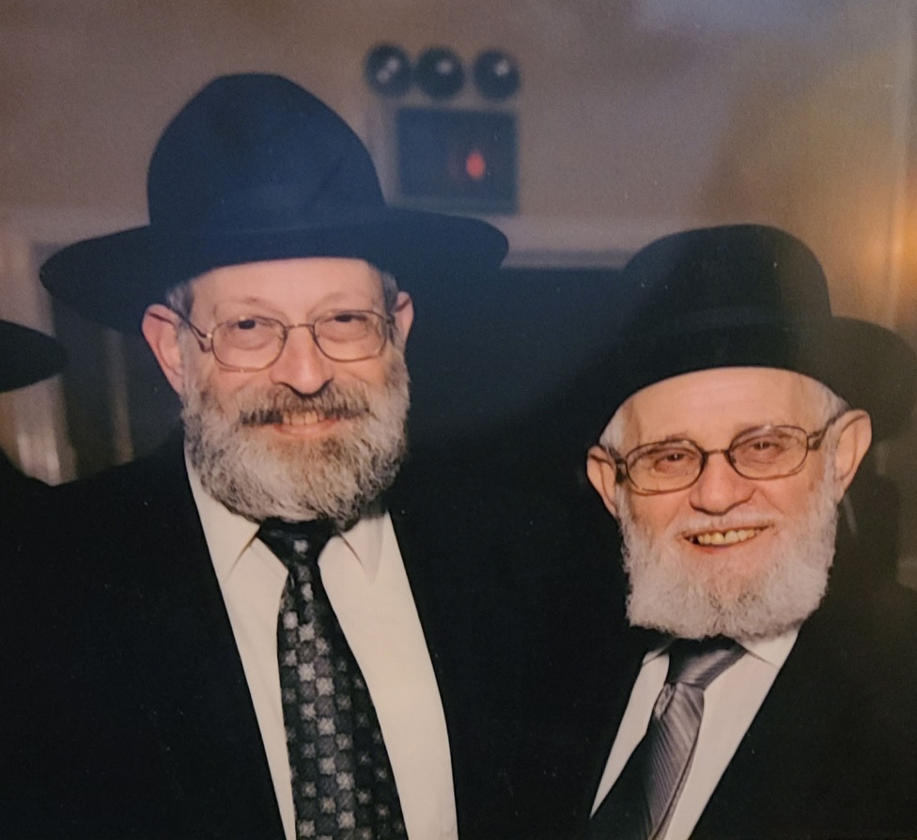
Rabbi Avi Shafran, left, and his father, Rabbi Simcha Shafran.

I came to realize his reticence had been because he hadn’t wanted to burden my sister, brother and me with the weight of the harrowing years of his youth.
How, for instance, at the age of 14 in his native Poland, Simcha Bunim Szafranowicz — the name he was born with — had stubbornly insisted his parents let him study in yeshiva, even though what would come to be known as World War II had begun mere weeks earlier, and the family was fleeing the approaching Nazis.
How SS men who had caught up with his family and other refugees from their town, Ruzhan, killed his uncle in front of him and packed my father and hundreds of other Jews into a synagogue, locked them in and set fire to neighboring homes. Preparing to die, the Jews were rescued at the last minute by a German army official who passed by and ordered the Jews to be let out. It was the Prophet Elijah, they suspected — who, in Jewish tradition, appears throughout history to save Jews — here, in strikingly unusual disguise.
How the boy’s parents reluctantly gave him their blessing — they didn’t know, after all, where would be the safest place for him — and said goodbye to him. As it turned out, for the last time.
That was the beginning of a journey that would take young Simcha to Siberia, and then America, where, as Rabbi Simcha Shafran, he would become a revered, beloved rabbi of a congregation.
In the fall of 1939, the boy who would become my father, holding his tefillin — the small leather boxes holding pieces of parchment with certain Torah verses on them, bound to leather straps and placed on one’s arm and head — and some apples his mother had given him, set out for the Novardok Yeshiva in the Polish town of Bialystok.
En route, he discovered that all the Polish yeshivas had relocated to Vilna, Lithuania. In the train station, he recalled, he heard and heeded a voice in his head crying “Simcha! Get on the train!” to Vilna, and managed to pull himself onto the platform between two cars.
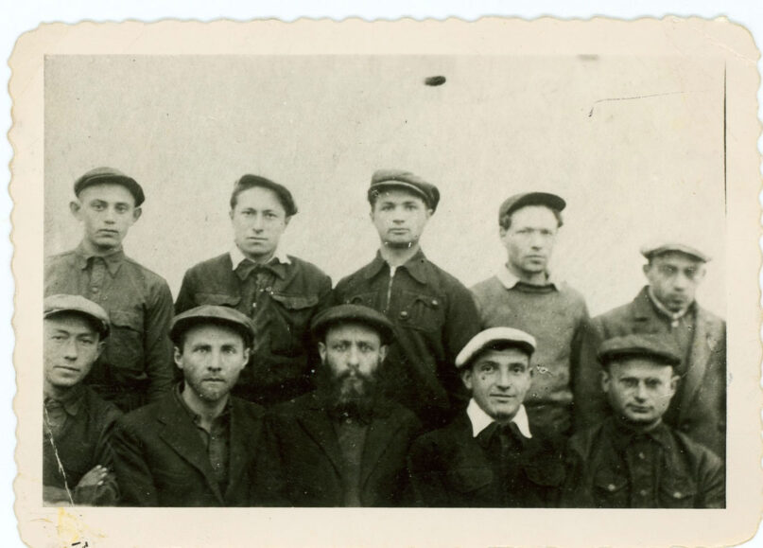
Rabbi Simcha Shafran as a boy, top left, after being released from Siberia.

Rabbi Simcha Shafran as a boy, top left, after being released from Siberia.
He ended up in the relocated Novardok Yeshiva in a Lithuanian town called Birzh, where the yeshiva functioned until the Soviets took over in 1941 and demanded that all refugees become Soviet citizens.

Refusing the Offer of Soviet Citizenship
My father and his fellow students knew that accepting Soviet citizenship would have made them cannon fodder in the army, and they refused the offer. As foreign nationals, they were put on cattle trains, with a hole in each car’s floor acting as a toilet, and, weeks later, arrived at a Siberian work camp, where they were ordered to fell trees, chop wood, harvest grain and grind it.
My father was the youngest of the group that spent the rest of the war in the frozen taiga, along with their teacher, Rabbi Yehudah Nekritz.
When working, they would discuss Talmud lessons or recite Psalms. They would not allow the Soviets to rob them of their spiritual heritage. In their shelter, they always had a chessboard, mid-game, in front of them, in case their overseer — who hated religion — should stop by.

An Assortment of Tricks to
Avoid Working on the Sabbath
The exiles used an assortment of tricks to avoid working on the Sabbath, clandestinely baked matzos for Passover and jerry-rigged a sukkah, a special hut, in the middle of the night to observe the Sukkot festival.
The group survived those years. In 1944, the young men were transferred westward and eventually smuggled into Berlin’s American zone. My father had a bullet wound scar on his arm from when a bribed guard betrayed them and sprayed the truck they were in. I was in my 30s, I think, when he first showed me the scar.
The refugees organized a yeshiva in a town near Frankfurt and resumed their Torah studies. In June 1947, after establishing contact with a relative in the U.S. willing to sponsor him, my father arrived at Ellis Island.

Buying a New Pair of Tefillin
With the $75 given to him by a Jewish social service organization, he bought a new pair of tefillin, his old ones having been well-weathered by Siberia.
In New York, he met the daughter of a respected Baltimore rabbi, Noach Kahn, and courted her. They had only Yiddish in common, and my father, impoverished but resolute, dated my mother by taking walks with her, sometimes subway rides, and singing songs from his yeshiva days. He had a sweet voice and what struck everyone as perfect pitch.
The couple moved to Baltimore and my father became the rabbi of a small synagogue. He picked up English quickly, thanks largely to my mother, who helped him translate sermons he wrote in Yiddish into English.
His income from the synagogue was paltry, and so, even with the counseling, weddings, funerals and hospital visits, my father found the time to attend night school to study accounting. In addition to his rabbinic responsibilities, he became an auditor for the city of Baltimore. He took his obligations seriously, and his co-workers were impressed by his integrity. They said they could set their watches by when he left for lunch break and when he returned to his desk.

Presenting Himself and Judaism
Honestly without Pretensions
Throughout his more than 60 years as a rabbi, my father made deep impressions on young and old, seekers and scoffers, intellectual and spiritual sorts alike. There wasn’t any trick. With his radiant smile, he just presented himself, and Judaism, honestly, without pretensions. Someone once remarked that he had always assumed that to be a successful rabbi in America, a man had to be tall and sophisticated, speak the Queen’s English and hold himself aloof — until he met my father.
Rabbi Simcha Shafran at one of his great-grandchildren’s circumcision ceremonies. Photo courtesy of Avi Shafran
When, after more than 40 years of marriage, my mother died in 1989, my father was devastated. But the inner strength that saw him through so much emerged with time and he resumed his life with vigor, even marrying again. His second marriage lasted for 20 years. When my stepmother fell ill, my father cared for her, as he did for my mother, during her final illness.
He walked 3 miles daily, well into his upper 80s. In 2012, he published his memoir, “Fire, Ice, Air: A Polish Jew’s Memoir of Yeshivah, Siberia, America.” Only a brain tumor slowed him down and, eventually, ended his life.
On his last morning in this world, he made a final request. It was hard to understand him, but his daughter-in-law said she heard him say “tefillin.” When she asked him if that was what he wanted, he nodded yes, and my brother fetched my father’s tefillin and placed them on my father’s arm and on his head. It was then, after fulfilling that observance, that my father relinquished his soul.
On the final day of the Jewish week of mourning, a baby boy was born to one of our sons. At the child’s circumcision, he received his name, and a new Simcha Bunim Shafran entered the world.

(Rabbi Avi Shafran writes widely in Jewish and general media.)

